**34. Install the chart**

--- **note** - Before we deep dive into the files and folders under our chart, let us do a release or installation using the firstchart that we have created now. go to the command line and execute helm install.

--- This time we are not going to use Bitnami slash some chart name. We are using our own chart, which is firstchart.

**# Create release or installation using our chart**

--- helm install firstapp firstchart

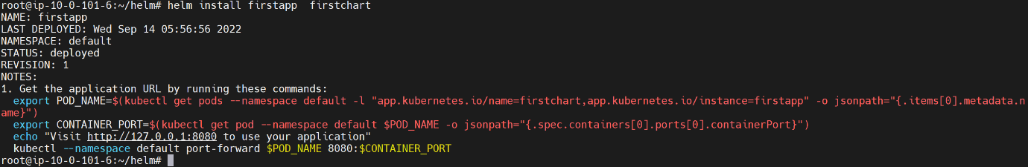

--- **note** - this chart is off type nginx by default, so nginx will be run on a kubernetes pod.

**NOTES.txt**

--- **note** – NOTES.txt file is under template folder, you can find the release notes in this file.

-- cat /firstchart/templates/NOTES.txt

